

Simulation ALBATROSS II

Date | 23.10.2026
Participants | Diego Grünberger, Ciel Frey

Configuration
Rocket
Total mass dry [kg]: 11,894
Total mass wet [kg]: 16,968
CG from tip wet [m]: 1,324
CP from tip at rail exit [m]: 1,557 (OpenRocket); 1,652 (RocketPy)
Stability at rail exit (@ 2 m/s wind) [cal]: 1,84 (OpenRocket); 2,5 (RocketPy)
Thrust to weight ratio at rail exit: 16,48
Motor: 9977M2245-P
Fin span [m]: 0,328
Fineness ratio: 17,26

Launch rail
Length [m]: 7
Heading [°]: 40
Inclination [°]: 3

Simulation Settings
Simulation 1
Standard OpenRocket environment settings (2 m/s surface wind speed, 0,2 m/s standard deviation, wind direction 90°)
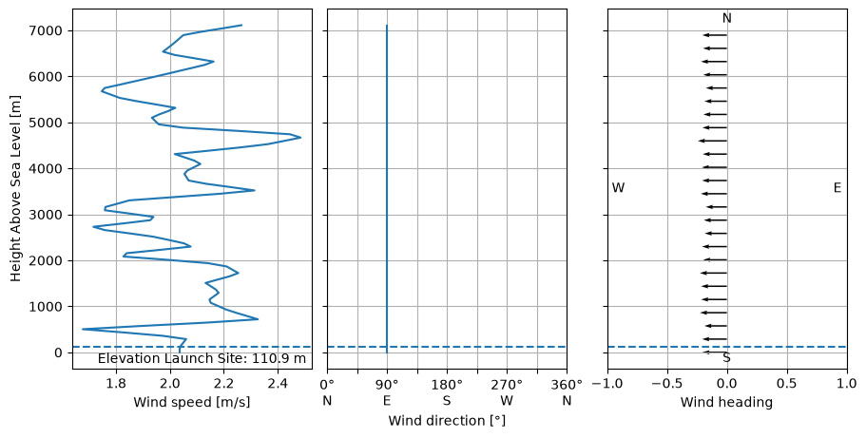
Landing positions will be simulated for 0-10 m/s wind speed.

Simulation 2
real weather data from launch site
Surface wind speed: 3,31 m/s
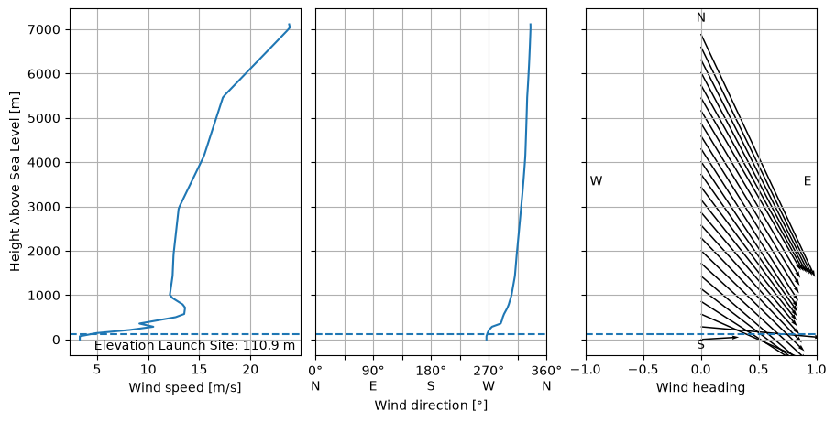

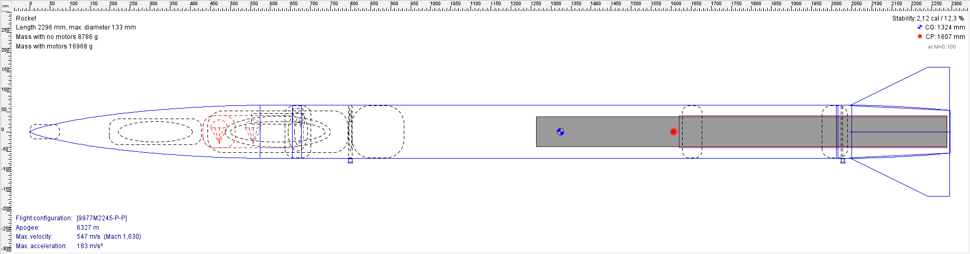

Results
Environment independent results:
 | OpenRocket | RocketPy
Rail departure time [s] | 0,296 | 0,287
Velocity at rail exit [m/s] | 42,1 | 40,7
Maximum speed [m/s] | 547 | 544,2
Maximum Mach Number | 1,63 | 1,63
Maximum acceleration [m/s²] | 183 | 182,2
Maximum Gs [g] | 18,7 | 18,58

Simulation 1 (2 m/s wind speed):
 | OpenRocket | RocketPy
Apogee [m] | 6307 | 6356
Impact speed [m/s] | 5,72 | 5,55
Apogee time [s] | 32 | 32
Total flight time [s] | 300 | 300

Simulation 2 (real weather data):
 | OpenRocket | RocketPy
Apogee [m] | 6298 | 6277
Impact speed [m/s] | 6,84 | 5,48
Apogee time [s] | 32 | 32
Total flight time [s] | 301 | 300

Stability plot
OpenRocket
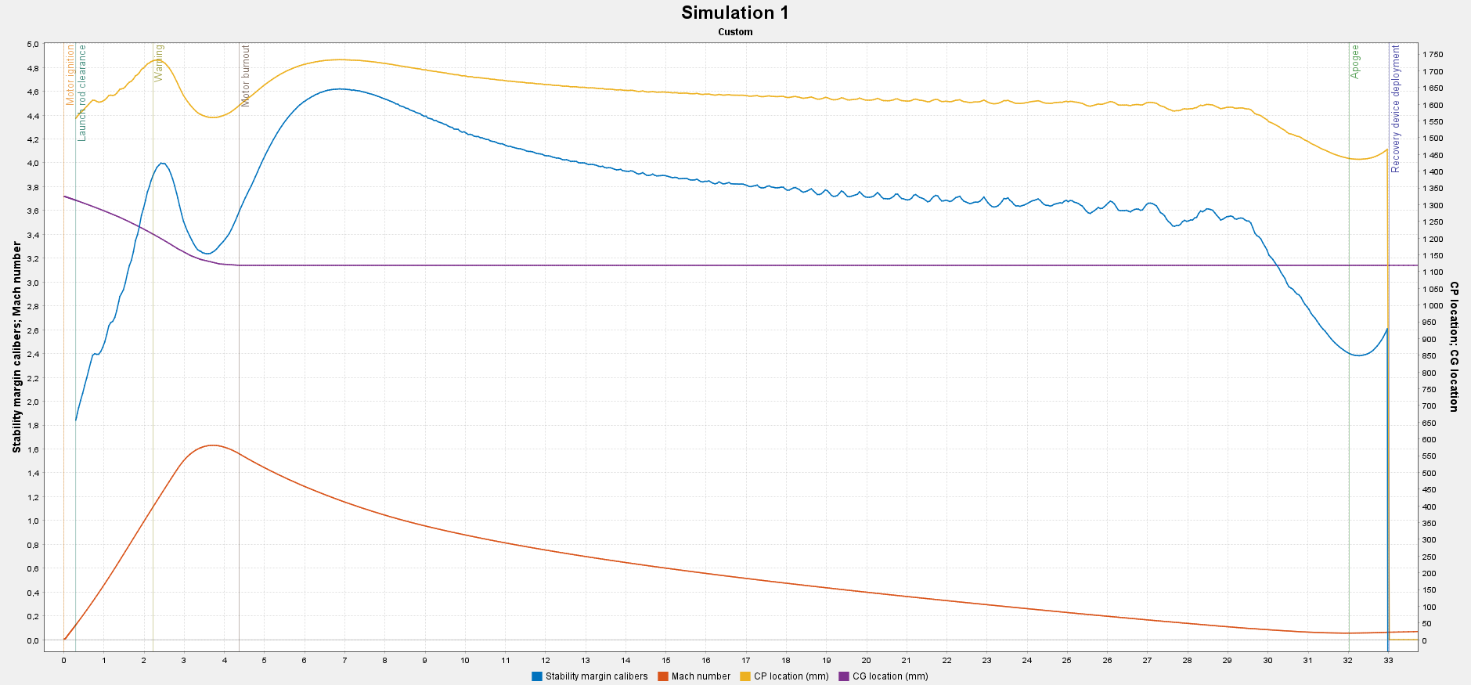

RocketPy
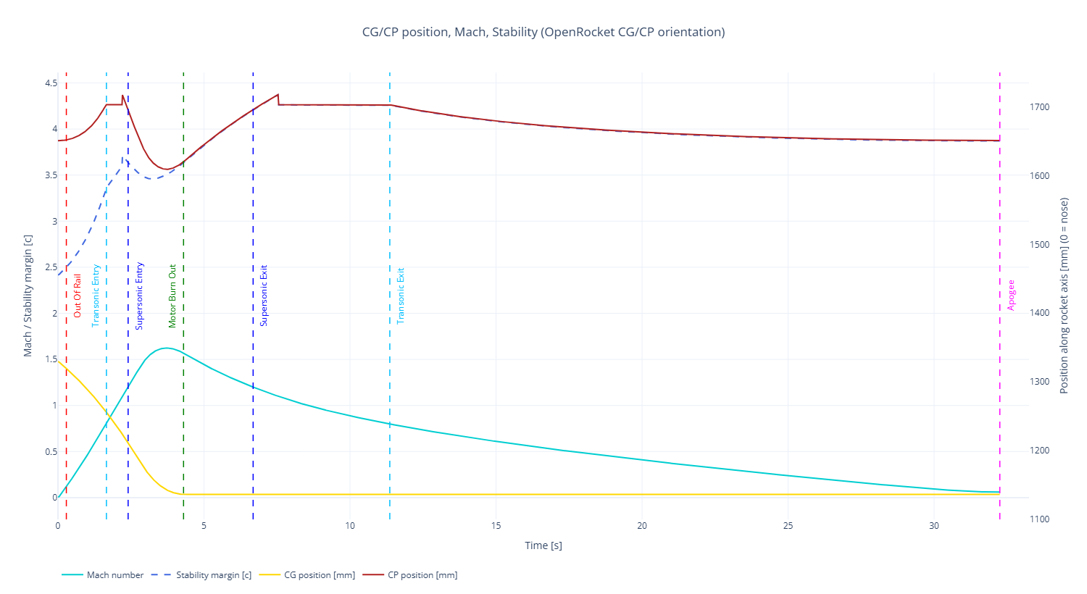

Total motion over time
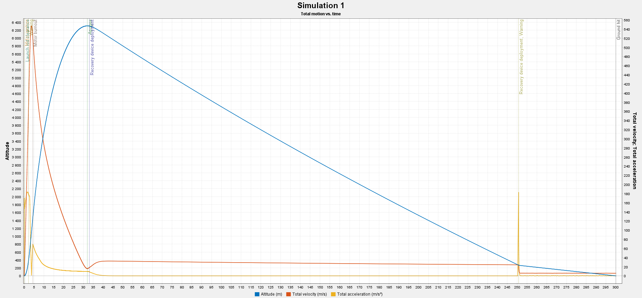

Trajectory
Simulation 1 (2 m/s wind speed)
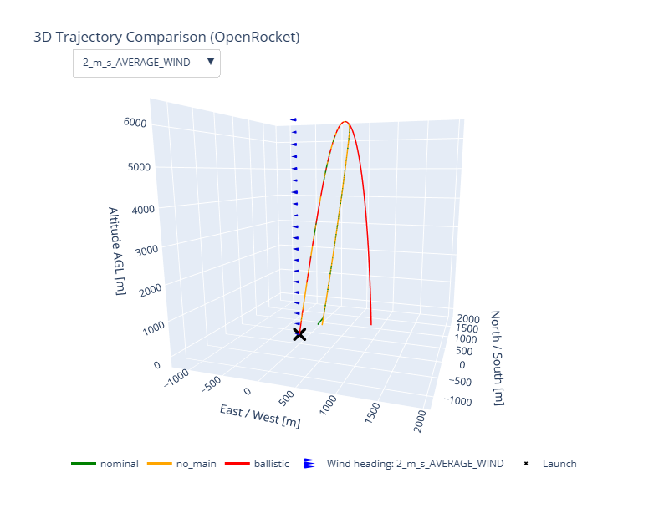

Simulation 2 (real weather data)
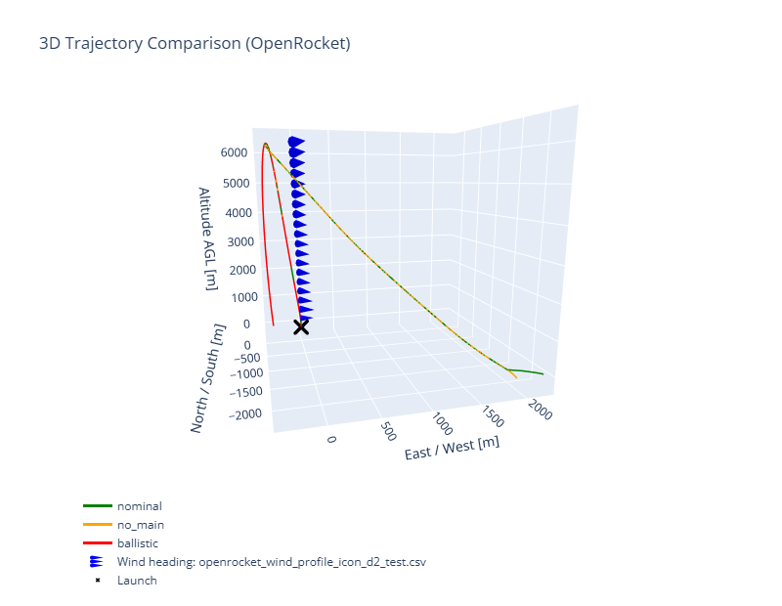

Landing positions
Simulation 1 (0-10 m/s wind speed)
Nominal furthest west for 10 m/s; furthest east for 0 m/s
No main furthest west for 10 m/s; furthest east for 0 m/s
Ballistic furthest west for 0 m/s; furthest east for 10 m/s

Classified as “suboptimal” since it lands in a forest if it flies ballistic.

OpenRocket
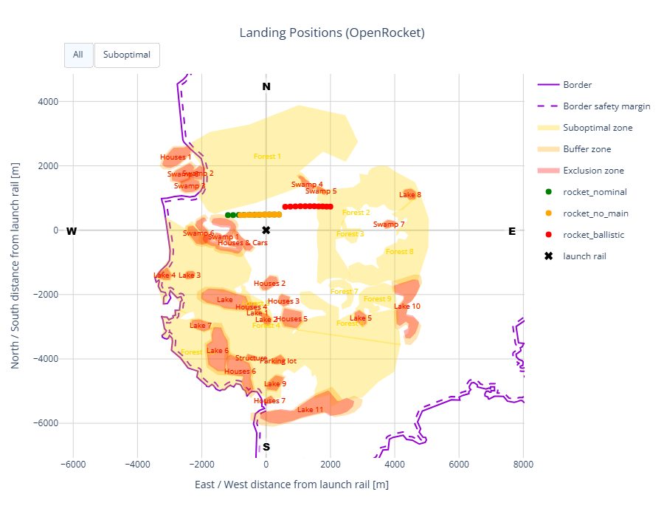
Landing distance from launch rail
nominal [m]: 487 - 1276
no main [m]: 485 - 926
ballistic [m]: 937 - 2126

RocketPy
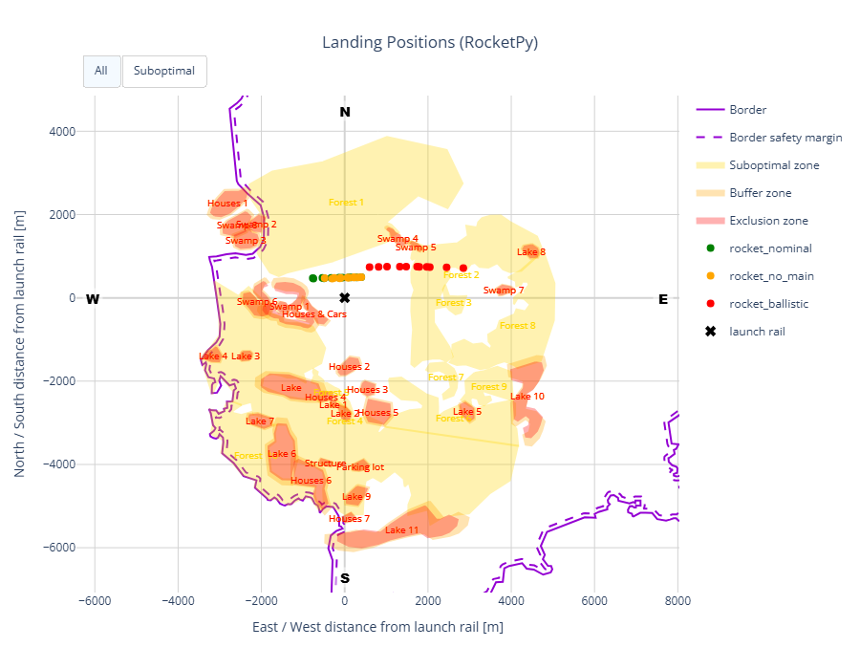
Landing distance from launch rail
nominal [m]: 489 - 902
no main [m]: 485 - 677
ballistic [m]: 951 - 2938

Simulation 2 (real weather data)
Heading [°]: 40, 50, 60
Inclination [°]: 3, 4, 5

Classified as “suboptimal” since it lands in a forest if it flies nominal/with no main.

OpenRocket
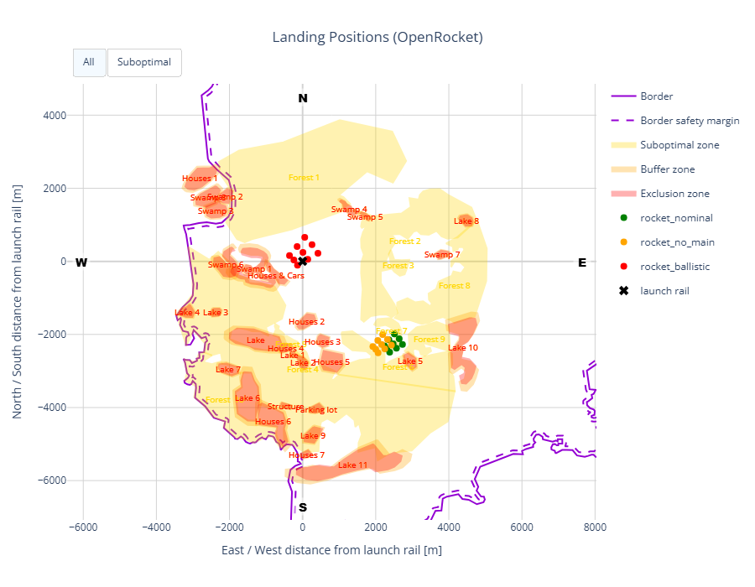
Landing distance from launch rail
nominal [m]: 3194 - 3554
no main [m]: 2969 - 3338
ballistic [m]: 152 - 658

RocketPy
Some flights classified as “suboptimal” since it lands in a forest if it flies nominal/with no main.
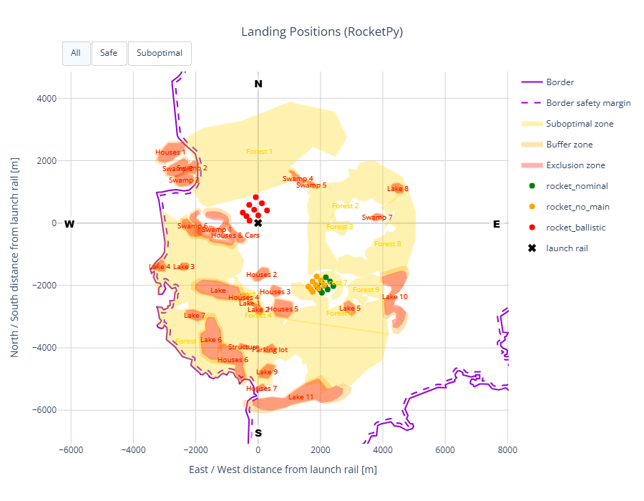
Landing distance from launch rail
nominal [m]: 2782 - 3149
no main [m]: 2540 - 2910
ballistic [m]: 242 - 835

